Module 01 Course Project [- Incorporating Decision Structures](https://learning.rasmussen.edu/webapps/assignment/uploadAssignment?content_id=_5418037_1&course_id=_60827_1&group_id=&mode=view)

Shaun Pritchard

Rasmussen College

COP1350c Section 01 C++ Programming

Mortoza Abdullah  
January 18, 2020

Module 01 Course Project [- Incorporating Decision Structures](https://learning.rasmussen.edu/webapps/assignment/uploadAssignment?content_id=_5418037_1&course_id=_60827_1&group_id=&mode=view)

**Contact manager program:**

Main menu  will use cin to gather user input to decide to access program object commands listed. Each menu item will consist of programmatic features to simulate CRUD operations for adding, storing, editing, reading, and deleting contacts as displayed in diagram 1:1:

* Add new contact
* List All contacts
* Search for contact
* Edit a contact
* Delete the contact
* Exit program

**Main Console Menu**

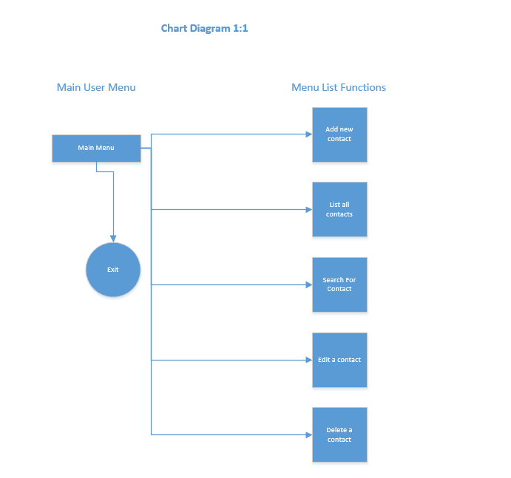

**Exit process:**

The exit function will take user input cin value 0 is entered and run a break function on the program to end the program. Depicted in diagram 1:2

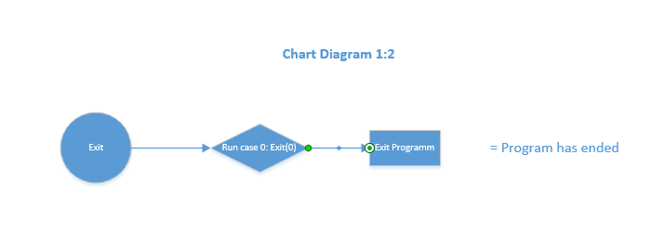

**Add Contact:**

Create contact function will use cout to display user fields and user information. In regard to the phone number name address and email of the contact in question.  Using cin to get user input data for the specific fields. then stored in index character array objects stored in dat file write object. cin user input will ask user to save the contact to the arrays or have an option to delete the contact by looping through the index values and removing the enter values via the array while loop. As depicted in diagram 1:3

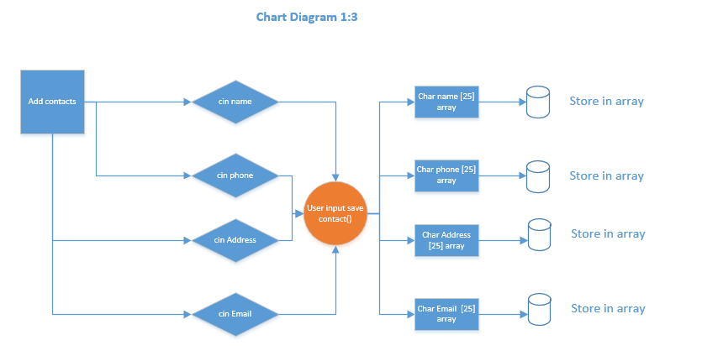

**Search for contact**

This function will need to access the data arrays, via user input command. Then loop through the data array objects based off the user input of the phone number. I want to revert from using the name, address, or Email array in case there are duplicate array values persisting in the wrong selection. This would yield and wrong results for the search. It will then fetch the data and display the results in the console. Ultimately displaying the results in the user console. As depicted in diagram 1:4

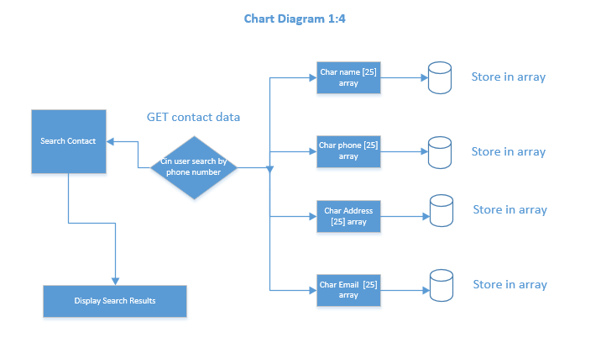

**Edit a contact**

This function will have to read through the data file arrays to find the contact. When is is found it will use the show cin function followed by a while loop. Execute reading the data in the indexes displaying new user inputs to replace the original data in the array index object with the new user input. As depicted in diagram 1:5

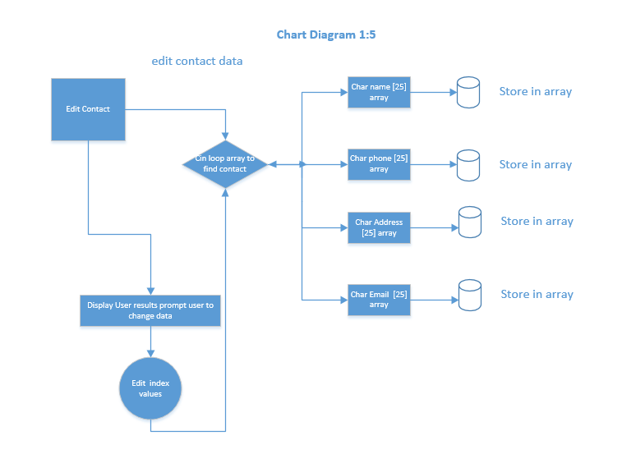

**Delete the contact**

This function will need to access the arrays in similar fashion to the search accessing the data array objects where the data is stored and remove the index value of the data hence deleting the contact fields in each array for each index in their respective array. As depicted below in 1:6.

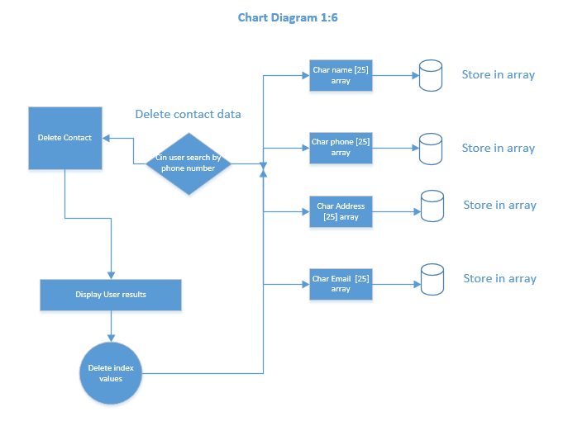

This is an outline of the CMS Contact manger software in C++ I am currently underway building for the class project.